

**Practice Information**

**for Patients**

**The White House Surgery   
GMS Practice**  
**1 Fairfax Rise, Sheffield, S2 1SL**  
 [SHECCG.WhiteHouseSurgery@nhs.net](mailto:SHECCG.WhiteHouseSurgery@nhs.net)   
www.whitehousesurgery.org

0114 2245878  
Monday 8.00am-6pm  
Tuesday 8.00am-6pm  
Wednesday 8.00am-6pm  
Thursday 8.00am-4pm  
Friday 8.00am-6pm  **To order prescriptions please ring the above number from 10.00-6.00 Monday– Friday**

**Welcome to The White House Surgery current patients and new!** The GP partners are an established team of doctors dedicated to the health and wellbeing of the community that they serve. The surgery has a special   
interest in medical training and are very proud to help our future medical staff! These include fully qualified doctors undertaking further training to become GPs or Nurse’s.   
We also assist in the training of medical students. If a medical student is sat in your   
consultation, we are grateful for your assistance, although please let   
reception know if you would prefer to be seen alone.

**How to register at White House Surgery**  
If you would like to register at the White House Surgery, please check with   
reception that you live within the practice boundary. If you are the receptionist will ask you to complete a   
registration form and a new patient questionnaire.   
Once this is complete you can book an appointment as necessary.

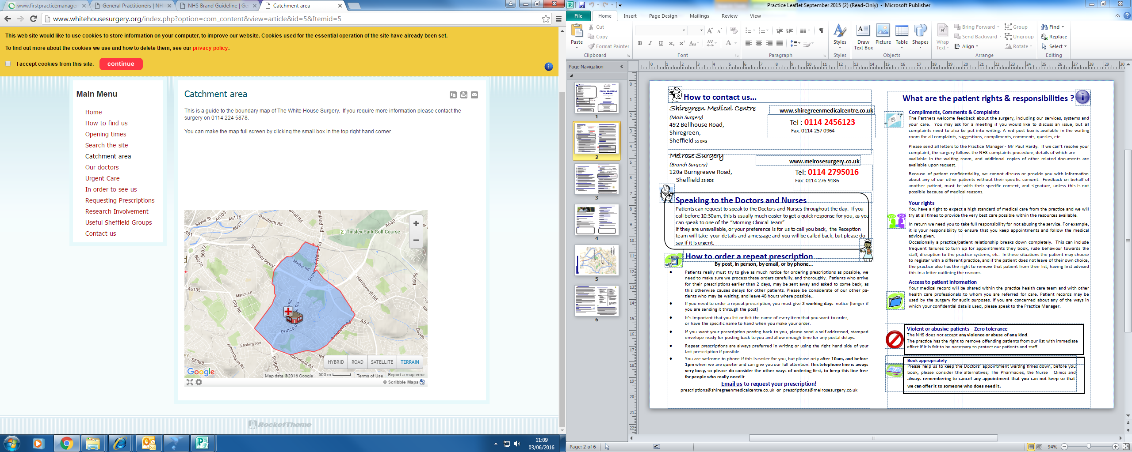

**Mobility Difficulties?**   
Our premises offer full disabled access along with disabled parking. All of our consultation rooms are located on the ground floor.   
**Do you have difficulty hearing/understanding English?**We can book interpreters for sign language as well as most other languages. We also have an hearing loop installed at the practice.

**Access to patient information**  
Your medical record will be shared within the practice healthcare team and with other healthcare professional to whom you have been referred to for care. Patients records may be used by the surgery for audit purposes. If you concerned about any of the ways in which your confidential data is used, please speak to the Practice Manager.

**Online services**If you wish to order your prescriptions, please bring in a form of photo ID and reception will set you up for this service.

**How to make an appointment***Please book appointments appropriately, this helps us keep the wait for Doctors   
appointments down. We recommend you seek advice from NHS choices or the   
Pharmacist if you are unsure if you need to see a Doctor or Nurse.*   
Appointments are available between 8.30am -6pm, apart from Thursdays when we only have a morning surgery. We offer early morning appointments (before 8am) and HUB appointments on evenings and weekends, these are all pre-bookable appointments aimed at workers who can’t get into normal surgery appointments.  
Patients have the right to choose which Doctor or Nurse they wish to see, although if you do wish to see someone in particular, the wait time maybe a little longer.   
**Book on the day appointments**  
If the feel your problem is urgent and cannot wait until the next available routine   
appointment, then you can request a same day appointment. If you are acutely unwell on that day you can call the surgery between 8.30 9.30 to speak to the urgent care team who will triage your problem and if necessary give you an appointment for the same day. The receptionist may ask if you feel your problem is urgent for that day, this is to ensure we use the urgent appointments appropriately.   
**Home visits**If you consider yourself too ill to attend surgery, please phone the surgery before 10am (if possible). A Doctor will usually call you back first to check a visit is necessary.   
**If the surgery is closed**  
If the surgery is closed and you need to see an **emergency GP,** please call the surgery and you will be transferred to the out of hours service, alternatively you can call 111.   
**Sheffield Walk-in centre** (Broad Lane, S1 4BT)  
Any time between 8am-10pm, patients will be seen by a Doctor or Nurse without an appointment.  
 **Please cancel your appointment if you no longer need it!**

**How to order a repeat prescription**You can order your prescriptions Monday-Friday over the phone from 10.00—6.00pm. Alternatively you can use our online system, drop it into surgery or post it us. (Please allow longer for postal orders, if you wish for your prescription to be posted back please send a stamped self addressed envelope).Please allow at least 2 days notice when ordering a repeat prescription. We need to make sure we process these orders carefully and thoroughly. Patients who arrive for their   
prescriptions earlier than 2 days, may be asked to come back.

Please also beware that the pharmacy may need longer time to prepare your medication.

**Services available at the practice**

|  |  |
| --- | --- |
| **Core services** -General management of medical conditions -Health promotions advice  -Emergency care -Referral for other services  -Urgently required care for  temporary residents. | **Additional Services** -Cervical screening  -Contraception services  -Vaccinations & immunisations  -Childhood & preschool immunisations  -Child health surveillance -Maternity services  -Minor surgery procedures -Contraceptive implants |
| **Enhanced Services**  -Minor surgery  -Improved access -Childhood immunisation scheme  -Influenza & pneumococcal immunisation scheme  -IAPT & Counselling  -Nursing home -Homeless shelter  -Data quality  -Extended access -Implanon (Contraceptive implants) | ***If you are unable to attend the  surgery for any reviews or checks,  a homevisit maybe required.  Please speak to reception for  further information*** |

**How to request private paperwork / signatures**  
Requests for the Doctors or staff to sign paperwork, fill out forms and write reports for patients is often classed as private (non-NHS) work. This can include reports for insurance or solicitors, medical examinations for HGV drivers, fitness to fly, passports, private letters etc.   
All such requests should be left with reception to pass on to the Doctor.   
Do not book an appointment for the purpose of getting forms completed and signed. This will not be done during a consultation.   
The partners reserve the right to charge a fee for all private reports, examinations and   
signatures that fall outside the NHS contract and any such work is only agreed entirely at the discretion of the partners. The fees depend on the amount of admin work and GP time   
involved in reading, researching, processing, completing reports, copying and tidying up. Please ask details for current rates.

|  |  |
| --- | --- |
|  |  |
|  |  |

**Your rights**   
You have a right to expect a high standard of medical care from the practice and we will try at all times to provide the very best care possible within the resources available.   
In return we ask you to be respect the service, for example attending appointments or cancelling if not needed.

**Compliments, comments and complaints**   
The partners welcome feedback about the surgery, including our services, systems and your care. Complaints can be made in writing or you can discuss your issue with a   
manager.   
Due to patients confidentiality, we cannot discuss or provide you with information about any of our other patients without their signed consent, unless this is not possible due to medical reasons.   
We will investigate your complaint and respond within 10working days, by your preferred method of contact. If you feel we can’t resolve your complaint, the surgery follows the NHS complaints procedure, please ask a manager for more information.

**Violent or abusive patients—Zero tolerance**   
The NHS does not accept any violence or abuse of any kind!  
The practice has the right to remove offending patients from our lists with immediate effect if it is felt to be necessary to protect our patients and staff

**Partners at The White House Surgery**   
Dr Helen McDonough   
MBChB MRCGP DRCOG

Dr Elizabeth Wernham   
MBChB MRCGP

Dr Rhona Leadbetter  
MBChB MRCGP

**Salaried GP**  
Dr Tom Lawy

Dr S Mitchell

MB ChB FRCGP PhD   
  
**Nurses**   
Mrs Sally Smith-RGN  
Mrs Bernie Hill-RGN

Ms Heather Wallis—RGN

Ms Leah Binns—RGN

Ms Ruby Midgley  
  
**Managers**  
Mrs Lisa Allenby—Practice Manager

**SHEFFIELD CCG**For further details of Primary Medical Services in this area:  
 **Sheffield CCG Headquarters: 722 Prince of Wales Road, Darnall,   
 CCG Sheffield, South Yorkshire, S9 4EU**

Tel: (0114) 305 1000 Website: http://www.sheffield.nhs.uk/